Reporting No:1 Week No:1 From :13/05/2024 To :19/05/2024 College ID: 22AIML026

Project Title: student collage recommendation system

**WEEKLY REPORT**

**Work done in last week ( Attach supporting Documents):**

1. Write a program for student detail.

2. Using pickle to combine deta set.

3. Finding resources or available data from Kaggle.

4. Finding an e-commerce dataset

**Reason for incomplete work:**

1. Studying and analyzing machine learning algorithams

**Plans for next week:**

1. Learn tfid-vectorizer algorithm.
2. Collecting new data for Students in Canada.

**References:**

1. Neso academy (youtube)
2. Google

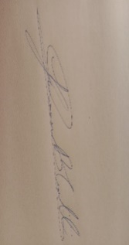

**Signature of External Guide Signature of Internal Guide**

Student Id: 22AIML026

Student Name: Yagnik Paghdal